FIFA Global Burden of Injury and Illness Project: Proposed Bayesian Methodology Version 2
  - Protocol version 2 | 9 September 2026
  - Green text marks text added or changed in Version 2.

1. Objective, Scope and Estimands
The FIFA Global Burden of Injury and Illness Project will synthesise injury incidence and time-loss burden across compatible eligible published football populations. Association football, futsal, beach football, para-football and other eligible disciplines enter the same coordinated programme only when their definitions and exposure denominators are compatible. Incidence and burden remain separate co-primary Bayesian analyses, each reported per 1,000 player-hours.
Planned outputs: Overall, match and training incidence, time-loss burden, discipline-specific estimates and supported location and injury-type analyses. Illness and mental-health methods are specified separately and are outside this injury methods summary.
The analysis therefore proceeds in sequence: harmonise the evidence, define non-overlapping analysis sets, fit the two primary outcomes, add only supported secondary analyses, and then test computation, prediction and sensitivity before reporting.

2. Harmonisation and Evidence Eligibility
Definitions and denominators: Map injury definition, exposure construction, setting and population variables to controlled values before fitting. Keep time-loss, medical-attention, all-complaints and physical-complaint definition families separate. Do not convert athlete-exposures, sessions or player-seasons to player-hours without a validated construction (Fuller et al., 2006; Bahr et al., 2020; Waldén et al., 2023). Athlete-exposure observations are excluded from the first analysis. Retain their underlying records for the separate planned year-long project; do not convert them to rates per 1,000 player-hours in this first analysis, even where a conversion has been validated. Directly compatible player-hour observations remain eligible.
Dependence and ownership: Use the governed denominator-owning row for overlapping source families. Retain distinct linked rows only when their non-overlap is established or their dependence can be represented without overstating precision (Senn, 2009). Overall, match and training results from one cohort must not be stacked as independent observations.
Setting-specific incidence: Estimate overall, match and training incidence separately. Match and training incidence are important planned analyses and will be incorporated wherever injury counts, player-hours, definitions and observation periods are compatible. Do not combine settings or treat overall, match and training rows from the same cohort as independent. Match- and training-specific burden estimates will be produced only where compatible directly reported or approved derived burden evidence provides adequate support (Bahr et al., 2020; Waldén et al., 2023).
Analysis-set freeze: Before modelling, preserve the exact input file and row version, resolve annotated or compound numeric fields, apply the denominator-owner policy, and record every inclusion, derivation and exclusion. The incidence, burden and linked incidence-severity sets may differ and must be versioned separately.
Follow-up and completeness: Record how each source handles injuries unresolved at study end, career-ending injuries and follow-up to return to play, with the source locator and unknown status where necessary. Record outcome-by-setting reporting completeness, distinguishing reported values, explicit zero, not reported and not applicable. Define whether each burden analysis targets observed-window days or complete injury episodes; separate incompatible follow-up constructions and pre-specify restricted analyses for incomplete or unclear follow-up.

3. Separate Co-Primary Incidence and Time-Loss Burden Analyses
Incidence: Model injury counts separately for overall, match and training settings, with the log of compatible player-hours as a fixed exposure offset. Use NB2 as the pre-specified primary likelihood for overdispersed injury counts, supported by predictive model assessment in sports injury data (Chandran and Lambert, 2025). Include study- or source-cluster terms only where repeated observations identify them. Retain valid zero counts and assess dispersion, zeros, tails and extreme counts with posterior predictive checks.
Working incidence model: For population i, let Yᵢ be the injury count, Eᵢ the compatible player-hours, d[i] the discipline and s[i] the study. The primary incidence model is:

Yᵢ ∼ NB2(μᵢ, κ), Var(Yᵢ) = μᵢ + μᵢ²/κ

log(μᵢ) = log(Eᵢ) + α₀ + δ(d[i]) + u(s[i]) + xᵢᵀβ

δ(d) ∼ Student-t₄(0, τ(disc))

Model parameters: μᵢ is the expected injury count; κ controls NB2 dispersion; log(Eᵢ) is the fixed exposure offset; α₀ is the common baseline log-incidence; δ(d[i]) is the discipline-specific deviation; u(s[i]) is the study-level deviation, included only when identifiable; xᵢ contains the pre-specified population characteristics; β contains their log rate-ratio coefficients; and τ(disc) is the between-discipline heterogeneity scale. Student-t₄ denotes a Student-t distribution with four degrees of freedom.
Model adequacy: Do not routinely fit Poisson or zero-inflated models. Use Poisson only if overdispersion is negligible or conclusions are likelihood-sensitive. Consider zero inflation only when a credible structural-zero process and unexplained excess zeros are both present.
Setting coherence: In cohorts with aligned overall, match and training observations, verify whether overall counts and hours equal the component sums, allowing documented rounding and other settings. Compare the overall result with the exposure-weighted match/training results for that same population and definition. This is a diagnostic, not a constraint across different study mixes. Separate-model draws do not identify the joint posterior of a difference involving reused data. A formal probabilistic coherence analysis requires a separately specified dependence model. Freeze the discrepancy statistic and materiality margin before fitting. Perform the match/training comparison only when those settings exhaust the overall numerator and denominator; otherwise include all aligned components or mark it inapplicable.
Time-loss burden: Restrict the separate co-primary burden analysis to compatible time-loss populations with directly reported or approved derived burden (Bahr et al., 2020; Pulici et al., 2023). Use Avinash's suggested approaches as the starting point for a pre-specified assessment, alongside explicit rules for unresolved and career-ending time loss. Assess two candidate total-days likelihoods: a compound Poisson-gamma model for non-negative totals with a defensible positive continuous severity approximation and a mass at zero; or an NB-type model only for genuine integer day totals with a justified mean-variance relationship. Compound Poisson-gamma is a full likelihood, not quasi-Poisson. Audit support, rounding, exposure scaling, follow-up and identification before selecting an eligible candidate. Reported or derived rates require an appropriate observation model for their available uncertainty; do not convert a rounded rate into an exact integer total or invent a standard error. Freeze the likelihood, priors and candidate-selection rule before fitting. These candidate choices require project-specific validation. The compound model is an actuarial analogy, not direct football validation (Smyth and Jørgensen, 2002).
Burden selection gate: Eliminate candidates incompatible with the observation scale or time-loss target, then require prior-predictive and simulation adequacy. If several remain scientifically plausible, compare them on the same held-out observations and scoring scale under the pre-specified validation target. Prefer the simpler adequate model when the difference is inconclusive. A discrete probability mass and a continuous density cannot be ranked as if they used the same observation measure; represent rounding consistently or keep that comparison as a sensitivity. If these approaches are unsuitable for the available measurements or fail validation, fall back to a justified alternative observation model under a recorded pre-fit amendment; if none is defensible, report descriptive burden. Do not select a likelihood merely because it was suggested. The linked frequency-severity analysis remains secondary.
Secondary linked incidence-severity analysis: For aligned injury counts, total days lost, player-hours, definitions, observation periods and case ascertainment, jointly analyse incidence and mean severity to assess whether burden differences reflect frequency, severity or both. This is explanatory and separate from the data-cleaning derivation. Do not combine incompatible summaries or estimate a separate cross-population incidence-severity correlation in the current plan.
Primary architecture: Do not create one multivariate primary incidence-burden hierarchy. The linked analysis is secondary and explanatory; it does not replace either co-primary analysis.
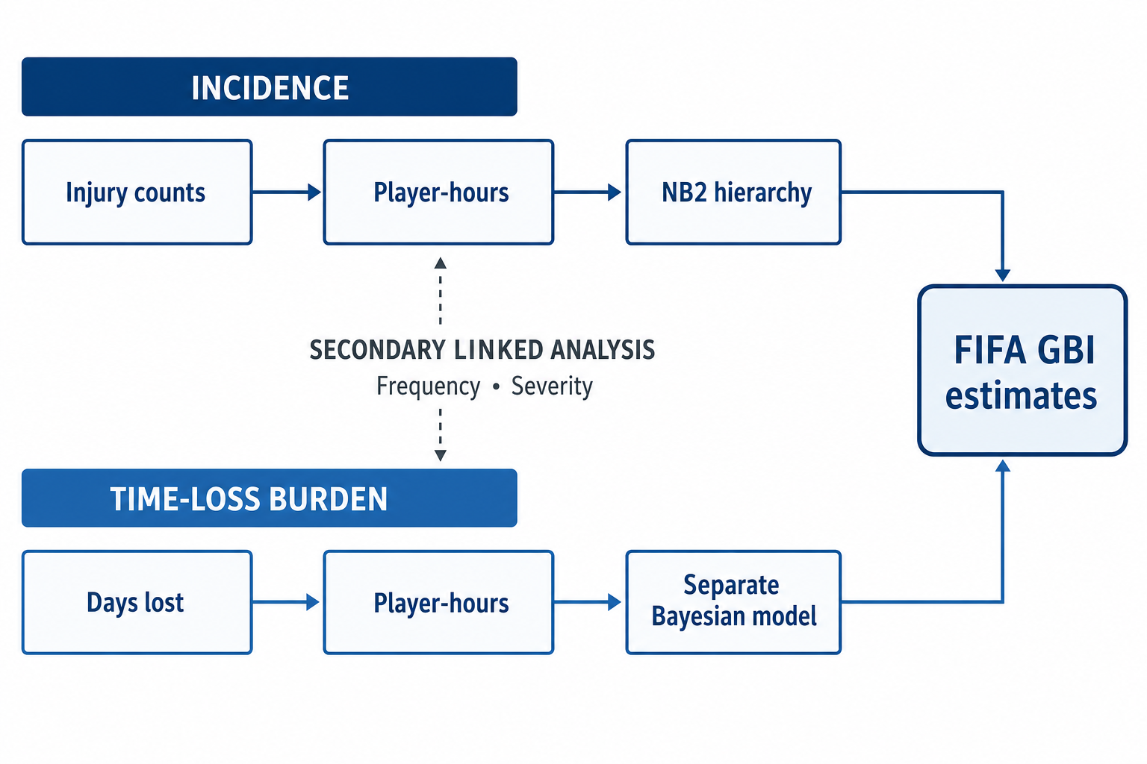
Figure 1. Co-primary FIFA GBI analysis architecture. Incidence and time-loss burden are modelled separately; the linked analysis is secondary and explanatory.

4. Robust Partially Pooled All-Disciplines Hierarchy
Fit one robust partially pooled hierarchy for each supported analysis set: overall, match and training incidence, and overall time-loss burden. Add setting-specific burden only if evidence passes the same gate. Each hierarchy has its own between-discipline heterogeneity parameter. Retain Student-t discipline effects with four fixed degrees of freedom. Prior-predictive and operating-characteristic simulations will compare this with a heavier-tailed Student-t variant and a Gaussian variant, under plausible and atypical discipline scenarios. These are assumption stress tests; a Gaussian observed-data sensitivity remains conditional on scientific justification and identification. Retain no-pooling and association-football-only sensitivities. Outcome posterior-predictive checks do not validate the discipline tail shape.
Borrowing: Borrowing is learned from independent source families, injury events or days lost, compatible exposure, within-discipline uncertainty and between-discipline heterogeneity. Association football is neither a reference truth nor a manual prior. Sparse disciplines may borrow strength but must retain wide uncertainty when the shared and discipline-specific evidence are weak.
Study and source-family levels: Include study-level variation where repeated comparable populations identify it. Add a source-family term only when distinct linked rows provide enough replication to separate that level from study variation and observation-level overdispersion. Freeze a design-specific replication rule and simulation recovery thresholds for each variance level, and compare study heterogeneity with NB2 dispersion in a variance-decomposition sensitivity. When replication across studies supports a study-effect distribution, single-row studies may receive effects from it, with their uncertainty retained. If that level is unsupported, omit it for the entire analysis set; those populations still share the discipline model. Do not impose a universal row-count threshold.
Variance and hierarchy gate: Repeated rows and uneven independent replication mean that raw row counts cannot establish a variance level. Set numerical operating thresholds before fitting. Simulations matching the observed replication must recover discipline contrasts and heterogeneity with acceptable calibration and bias. Assess variance separation, posterior uncertainty and sensitivity to reasonable prior changes. A near-zero heterogeneity scale can be valid; do not impose a universal minimum prior-to-posterior shift. If a level fails its recovery or identification gate, simplify or qualify it and foreground no-pooling results. Do not use a generic minimum number of disciplines.
Population characteristics: Candidate population predictors are sex, age and playing level, with country or region considered only at a supportable resolution. Discipline is represented by the hierarchy; setting and injury-definition families remain separate analysis sets. Freeze age representation and scaling, category/reference coding, geographical resolution, missingness handling and any supported interactions before fitting. Avoid stepwise outcome-driven selection and automatic inclusion of every available filter.
Borrowing sensitivities: Compare the robust hierarchy with no cross-discipline pooling and an association-football-only fit. Report changes in the common distribution, discipline estimates and uncertainty; do not assume association football will be unchanged.

5. Estimands, Priors and Predictive Checks
All-disciplines estimand: Report the common all-disciplines distribution and discipline-specific posterior rates from the joint model. Any combined headline is a pre-declared summary across eligible published populations using declared corpus weights. Define the headline from a finite declared corpus and weights at each posterior draw, then summarise its posterior with medians and quantiles. Unbounded Student-t log-rate effects have no finite exponential moments, so do not describe the arithmetic mean of the new-discipline rate distribution as a finite estimand. Audit extreme prior-predictive draws explicitly; a half-normal scale prior does not remove the Student-t effect tails.
Observed support: For every estimand, report contributing study populations, independent source families, injuries, player-hours and, for burden, days lost. Distinguish observed support from model-based prediction.
Prior specification: Use proper, parameter-specific weakly informative priors on interpretable rate, rate-ratio, dispersion and heterogeneity scales. Use calibrated half-normal priors as the primary heterogeneity-scale priors, with half-Cauchy retained as a reported sensitivity. Calibrate discipline, study and any source-family scale separately. Freeze the implied log-rate contrast quantiles and plausible rate-ratio limits before fitting. Calibrate NB2 dispersion using its additional relative variability or implied variance at representative means, alongside zero and tail behaviour. Record every parameter's density, support, scale or rate convention, units and numerical arguments (Röver et al., 2021).

Primary scale priors: τ(disc) ∼ Half-Normal(A_disc); τ(study) ∼ Half-Normal(A_study), when included.

Here A_disc and A_study are the standard deviations of the underlying zero-centred normal distributions, calibrated on the log-rate scale. They are not fixed to the same value by default. Half-Cauchy sensitivities use separately calibrated scales and retain the same scientific targets.

Prior predictive checks: Before fitting the observed data, draw parameters from the priors and simulate the planned evidence structure. Compare plausible ranges for counts, rates, zeros, maxima, total days lost, burden and discipline contrasts. Revise priors that routinely generate implausible football data, then record the final priors and simulation settings (Gabry et al., 2019).
Estimand freeze: Record the eligible population, outcome, exposure construction, setting treatment, burden formulation and likelihood, reporting weights, supported interactions, reporting thresholds, and the hierarchy operating criteria and numerical thresholds before the final fit.

6. Secondary Injury-Location and Injury-Type Analyses
Location and injury type are clinically useful secondary outputs, but their taxonomies and reporting completeness vary across studies. Analyse them only after the primary outcomes and only where categories can be harmonised without inventing information.
Taxonomy first: Map source categories transparently to approved location and injury-type categories, then model location and injury type separately. Treat an unreported category as missing, not zero, and retain ambiguous categories only as explicitly labelled residual groups (Bahr et al., 2020; Waldén et al., 2023).
Complete category sets: Where a population reports a complete, mutually exclusive category set, model counts jointly using a multinomial likelihood conditional on total injuries, with a hierarchical prior on category shares. Pre-specify the Dirichlet-multinomial as the overdispersed fallback. Trigger its evaluation only when the registered discrepancy statistics show material excess variation or concentration unexplained by the simpler model, with enough replication to identify the added dispersion. Validate either model by simulation and predictive checks.
Category-specific rates: Within each aligned category-composition analysis, combine posterior category shares with posterior incidence for the same compatible population and setting to derive category-specific incidence rates while propagating their joint uncertainty.
Scope limit: Do not add a location-by-type cross-classification unless enough compatible populations report that joint structure. Sparse, partial or non-exclusive category reporting remains descriptive or is handled in a separately justified sensitivity analysis. A composition conditional on an incomplete reported subtotal estimates shares of that subtotal, not of all injuries. Such records remain descriptive in the primary composition workflow. Their inclusion in a separate model requires an explicit reporting/observation mechanism and approval. Category-specific rates require aligned composition and incidence populations and a coherent joint or conditional uncertainty calculation.

7. Computation, Diagnostics and Reproducibility
Software: Implement the analysis in PyMC and use ArviZ for diagnostics and reporting. Validate the implementation with numerical checks, simulations, independent review and a reproducible rerun. Stan verification is optional and will be considered only if time permits and it adds little complexity or work; it is not a requirement for the primary analysis. NUTS applies to continuous unknown parameters; observed discrete counts do not prevent its use. Any discrete latent variable needs explicit marginalisation or an appropriate alternative sampling scheme.
Parameterisation check: Record PyMC NegativeBinomial with mu equal to μ and alpha equal to κ. If optional Stan verification is undertaken, the corresponding family is neg_binomial_2 with phi equal to κ; Stan's other negative-binomial family uses different arguments. Match distributions, not argument names. Verify log probabilities and implied moments on fixed fixtures, and check Student-t degrees of freedom and scale plus half-distribution scale conventions against the pinned software versions.
Execution: Start with validated outcome-specific components, then add supported study and discipline levels. Use at least four independently initialised chains and non-centred discipline and study effects as the starting parameterisation. Pre-specify the sampling backend, numeric precision, seeds, warm-up, retained draws, target acceptance and maximum tree depth. The proposed starting settings are 2,000 warm-up and 2,000 retained draws per chain, target acceptance 0.95 and maximum tree depth 12, subject to the pre-fit validation contract. Inspect energy, tree depth and divergences; diagnose implementation and parameterisation before revising scientific priors. Record all setting changes and reruns.
Computational gate: For every key scalar estimand, target rank-normalised R-hat below 1.01 and total bulk and tail effective sample sizes above 400 across at least four chains. Also require acceptable Monte Carlo error, no unexplained divergences and satisfactory rank plots. Visually inspect trace plots for mixing, stationarity and chain overlap. These diagnostics test sampling, not scientific validity (Vehtari et al., 2021).
Posterior predictive checks: Test model fidelity by comparing observed data with replicated data from the posterior. For incidence, compare counts, zeros, dispersion, maxima, tails and exposure-rate patterns. For burden, compare values, zeros and the right tail, stratified by direct or derived source. For category compositions, compare category shares, zeros and concentration. A material mismatch requires a documented model revision or limitation. Pre-declare each discrepancy statistic, comparison stratum and numerical materiality limit. Add full predictive-distribution calibration checks using randomised PIT or an equivalent discrete-aware method for count outcomes. Distinguish in-sample posterior-predictive checks from held-out calibration; account for source-family dependence and uncertainty. A nominal uniform-PIT test on fitted discrete observations is not a pass/fail shortcut.
Reproducibility: Retain the exact input and row version, SHA-256 hash, harmonisation maps, denominator-owner decisions, burden-derivation inputs, units and flags, formal model and priors, code, seeds, chain settings, software versions, platform details, diagnostics, predictive checks, sensitivities and machine-readable outputs. Seeds support reruns but do not guarantee bit-for-bit identity across environments.
Implementation verification: Require independently reviewed likelihood and parameterisation fixtures, simulation checks and a clean rerun of every final reported model in PyMC. Custom likelihoods and unresolved discrepancies require investigation and correction before the affected analysis can pass; they do not automatically require a second software implementation. Optional Stan verification is subject to the time and complexity conditions above. If undertaken, match data, priors, transformations and estimands, check both samplers and compare estimates using pre-declared scientific and combined Monte Carlo tolerances. Agreement tests implementation, not the scientific assumptions.

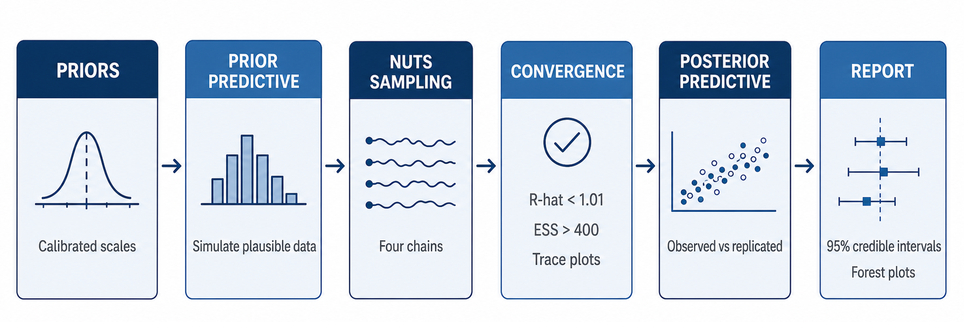
Figure 2. Bayesian workflow and decision gates. Priors are calibrated before fitting, NUTS convergence is assessed, and posterior predictive checks test model fidelity before reporting.

8. Sensitivity Analysis and Reporting
Pre-specified sensitivities: Compare the robust hierarchy with no cross-discipline pooling and an association-football-only fit. Also test plausible prior scales, direct versus approved derived exposure, directly reported versus approved derived burden, denominator-owner versus identifiable source-family handling, and the burden model against the eligible linked incidence-severity analysis. Recheck diagnostics and predictive adequacy for every reported fit. Carry half-normal versus half-Cauchy prior-family comparisons through to reporting. Include time-loss follow-up and study-appraisal restrictions where evaluable; record support lost under each restriction.
Predictive comparison: Specify whether the target is another row in a known study or a new independent study/source family. For the latter, hold out whole independent families and integrate over new random effects, using grouped cross-validation or refits when importance sampling is unreliable. Marginalising effects alone does not remove leakage from retained rows of the same family. Use the same test observations and scoring measure for compared models, and report score uncertainty and diagnostics.
Reporting order: Present incidence for overall, match and training settings and the separate co-primary time-loss burden results first. Follow these with supported discipline and population summaries, the secondary linked incidence-severity analysis, and the secondary location and injury-type analyses.
Intervals and displays: Report posterior medians with 95% equal-tailed credible intervals as the default, using the 2.5th and 97.5th posterior percentiles. Label prediction intervals separately and define whether they concern a latent rate or a new observation. Use forest plots for discipline, study-population and main sensitivity estimates. Show the common distribution and predictive distributions in the main report, with rank, trace and other sampling plots in a diagnostic appendix.
Transparent report: Follow STROBE-SIIS and the football-specific IOC extension (Bahr et al., 2020; Waldén et al., 2023). Report analysis-set provenance, populations, definitions, exposure, settings, missing data, category mappings, the full model and priors, weights, diagnostics, predictive findings, sensitivities, deviations and limitations (Kruschke, 2021).
Study appraisal: Confirm the instrument and version used for the surveillance designs before analysis freeze, with domain-level judgements and source evidence. Reporting checklists are not risk-of-bias tools. Resolve important appraisal disagreements, report the judgements, and pre-specify domain-based restrictions or sensitivities for material risks such as exposure validity, ascertainment and incomplete follow-up. Do not convert a checklist total into an arbitrary numerical study weight.
Living updates: At each approved update, preserve the previous release and freeze a new analysis set. Refit the full updated dataset under the frozen specification and original priors; do not reuse the old posterior as a prior while including the same old data again. Record evidence additions, corrections and methodology amendments separately. Confirm the review cadence and early-update triggers before first release, and report changed conclusions against the pre-specified materiality margins.

Reference List
- Abril-Pla O, Andreani V, Carroll C, et al. PyMC: A Modern and Comprehensive Probabilistic Programming Framework in Python. PeerJ Computer Science. 2023;9:e1516. doi:10.7717/peerj-cs.1516.
- Bahr R, Clarsen B, Derman W, et al. International Olympic Committee Consensus Statement: Methods for Recording and Reporting of Epidemiological Data on Injury and Illness in Sport 2020. British Journal of Sports Medicine. 2020;54:372-389. doi:10.1136/bjsports-2019-101969.
- Chandran A, Lambert B. Bayesian Methods for Estimating Injury Rates in Sport Injury Epidemiology. Injury Epidemiology. 2025;12:31. doi:10.1186/s40621-025-00583-z.
- Fuller CW, Ekstrand J, Junge A, et al. Consensus Statement on Injury Definitions and Data Collection Procedures in Studies of Football Injuries. British Journal of Sports Medicine. 2006;40:193-201. doi:10.1136/bjsm.2005.025270.
- Gabry J, Simpson D, Vehtari A, Betancourt M, Gelman A. Visualization in Bayesian Workflow. Journal of the Royal Statistical Society Series A. 2019;182(2):389-402. doi:10.1111/rssa.12378.
- Kruschke JK. Bayesian Analysis Reporting Guidelines. Nature Human Behaviour. 2021;5:1282-1291. doi:10.1038/s41562-021-01177-7.
- Kumar R, Carroll C, Hartikainen A, Martin OA. ArviZ: A Unified Library for Exploratory Analysis of Bayesian Models in Python. Journal of Open Source Software. 2019;4(33):1143. doi:10.21105/joss.01143.
- Pulici L, Certa D, Zago M, Volpi P, Esposito F. Injury Burden in Professional European Football (Soccer): Systematic Review, Meta-Analysis, and Economic Considerations. Clinical Journal of Sport Medicine. 2023;33(4):450-457. doi:10.1097/JSM.0000000000001107.
- Röver C, Bender R, Dias S, et al. On Weakly Informative Prior Distributions for the Heterogeneity Parameter in Bayesian Random-Effects Meta-Analysis. Research Synthesis Methods. 2021;12:448-474. doi:10.1002/jrsm.1475.
- Senn SJ. Overstating the Evidence: Double Counting in Meta-Analysis and Related Problems. BMC Medical Research Methodology. 2009;9:10. doi:10.1186/1471-2288-9-10.
- Vehtari A, Gelman A, Simpson D, Carpenter B, Bürkner PC. Rank-Normalization, Folding, and Localization: An Improved R-hat for Assessing Convergence of MCMC. Bayesian Analysis. 2021;16(2):667-718. doi:10.1214/20-BA1221.
- Waldén M, Mountjoy M, McCall A, et al. Football-Specific Extension of the IOC Consensus Statement: Methods for Recording and Reporting Epidemiological Data on Injury and Illness in Sport 2020. British Journal of Sports Medicine. 2023;57:1341-1350. doi:10.1136/bjsports-2022-106405.
- Smyth GK, Jørgensen B. Fitting Tweedie's Compound Poisson Model to Insurance Claims Data: Dispersion Modelling. ASTIN Bulletin. 2002;32:143-157. Author manuscript: https://gksmyth.github.io/pubs/insuranc.pdf.

